Case Study: 1
Health Supplement

𝟮 𝗠𝗶𝗹𝗹𝗶𝗼𝗻 𝗗𝗼𝗹𝗹𝗮𝗿𝘀 𝗔𝗥𝗥! | 𝗡𝗲𝘁 𝗣𝗿𝗼𝗳𝗶𝘁𝘀 $𝟳𝟯𝟬,𝟬𝟬 𝗜𝗻 𝟭𝟮 𝗠𝗼𝗻𝘁𝗵𝘀 | 𝗬𝗢𝗬 𝟯𝟵𝟯% (Hook)

𝗠𝗮𝗿𝗸𝗲𝘁𝗽𝗹𝗮𝗰𝗲: United States
𝗖𝗮𝘁𝗲𝗴𝗼𝗿𝘆: Health & Wellness
𝗡𝘂𝗺𝗯𝗲𝗿 𝗼𝗳 𝗦𝗞𝗨𝘀: 17
𝗬𝗢𝗬 𝗚𝗿𝗼𝘄𝘁𝗵: 393%
𝗡𝗲𝘁 𝗘𝗕𝗜𝗧𝗗𝗔: 36.52%

𝗣𝗿𝗼𝗳𝗶𝘁-𝗙𝗶𝗿𝘀𝘁 𝗦𝗰𝗮𝗹𝗶𝗻𝗴:
Built a SKU-level scaling framework where ad budgets increased only after hitting target contribution margins
Rebalanced spend weekly based on net profit per SKU, not top-line ROAS
Deprioritized volume-only products and doubled down on high repeat-purchase SKUs.

𝗙𝗿𝗼𝗺 𝗧𝗿𝗮𝗳𝗳𝗶𝗰 𝘁𝗼 𝗧𝗿𝘂𝘀𝘁: 𝗕𝘂𝗶𝗹𝗱𝗶𝗻𝗴 𝗔𝗻 𝗢𝗿𝗴𝗮𝗻𝗶𝗰 𝗔𝗱𝘃𝗮𝗻𝘁𝗮𝗴𝗲:

Optimized listings around buying intent, not just keyword density
Used review mining to rewrite bullets, images, and A+ content around actual objections
Leveraged Amazon Posts and brand content to increase branded search and repeat visits
Result: Organic rankings strengthened, paid dependency dropped, and conversion rates improved across the catalog.

𝗣𝗣𝗖 𝗦𝘆𝘀𝘁𝗲𝗺 𝗕𝘂𝗶𝗹𝘁 𝗳𝗼𝗿 𝗖𝗼𝗻𝘁𝗿𝗼𝗹 — 𝗡𝗼𝘁 𝗖𝗵𝗮𝗼𝘀:

Campaigns segmented by intent (ranking, harvesting, defense, scaling)
Long-tail keywords prioritized to capture high-intent buyers at lower CPCs
Weekly pruning of wasted spend using search term isolation and placement controls.

𝗥𝗲𝘁𝗲𝗻𝘁𝗶𝗼𝗻 & 𝗟𝗧𝗩 𝗢𝗽𝘁𝗶𝗺𝗶𝘇𝗮𝘁𝗶𝗼𝗻:

Introduced SKU-specific Subscribe & Save incentives tied to reorder behavior
Improved post-purchase experience to increase repeat conversion
Identified cross-sell opportunities within the brand ecosystem
Result: Higher lifetime value per customer and more stable monthly revenue.

𝗢𝗽𝗲𝗿𝗮𝘁𝗶𝗼𝗻𝗮𝗹 𝗗𝗶𝘀𝗰𝗶𝗽𝗹𝗶𝗻𝗲 𝘁𝗵𝗮𝘁 𝗣𝗿𝗼𝘁𝗲𝗰𝘁𝗲𝗱 𝗠𝗮𝗿𝗴𝗶𝗻𝘀:

Demand forecasting tied to real-time velocity and review velocity
Inventory planning adjusted to avoid forced discounting and stockouts
Cost structure reviewed quarterly to protect contribution margin as volume scaled
Outcome: Growth without operational stress or margin erosion.
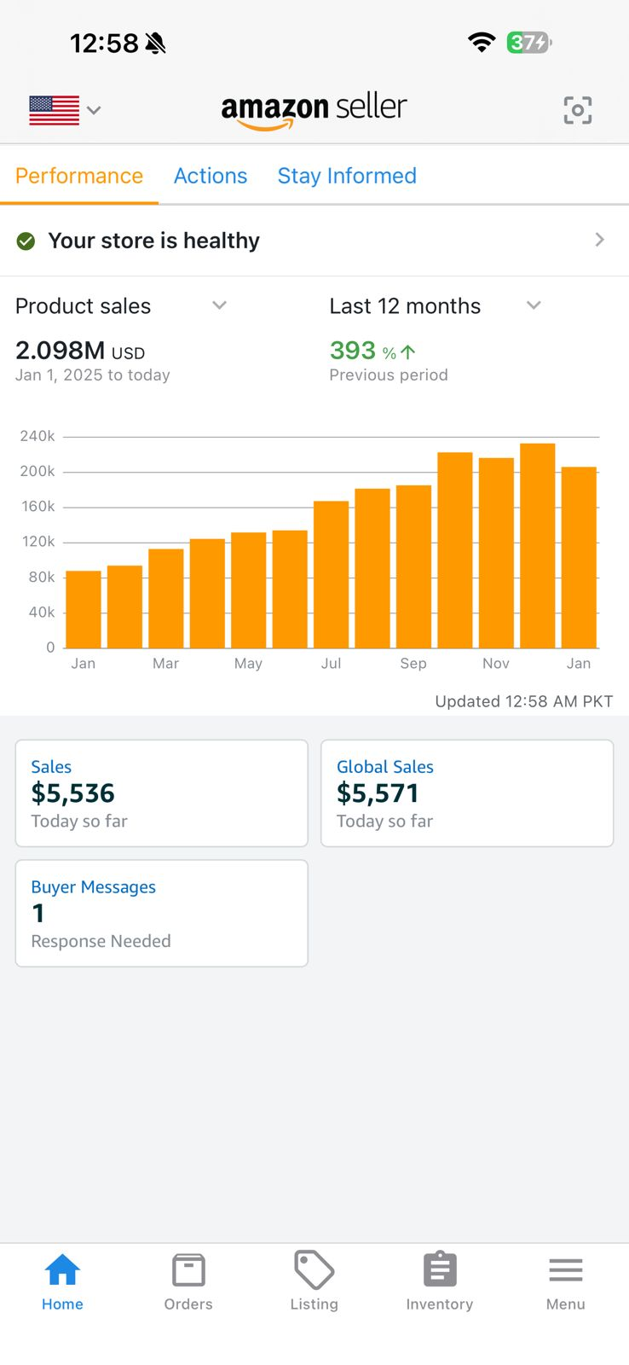

Case Study: 2
Home & Kitchen
𝗦𝗮𝗹𝗲𝘀 𝗼𝗳 $𝟱𝟱𝟳,𝟵𝟯𝟯 𝗬𝗧𝗗 𝗪𝗶𝘁𝗵 𝗧𝗔𝗖𝗢𝗦 𝗼𝗳 𝟱% 𝗼𝗻𝗹𝘆! | 𝗡𝗲𝘁 𝗣𝗿𝗼𝗳𝗶𝘁 $𝟭𝟱𝟱,𝟲𝟬𝟳 𝗝𝘂𝘀𝘁 𝗶𝗻 𝟭𝟭 𝗠𝗼𝗻𝘁𝗵𝘀! (Hook)
𝗠𝗮𝗿𝗸𝗲𝘁 𝗣𝗹𝗮𝗰𝗲: United Stats
𝗡𝗶𝗰𝗵𝗲: Home & Kitchen
𝗦𝗮𝗹𝗲𝘀: $557,933
𝗦𝗞𝗨𝘀: 21
𝗡𝗲𝘁 𝗘𝗕𝗜𝗧𝗗𝗔: 27.89%
This Kitchen & Dining brand operates in a highly price-sensitive, competitive category, where margin control, ranking stability, and operational efficiency matter more than aggressive spend.
𝗧𝗵𝗲 𝗥𝗲𝗮𝗹 𝗖𝗵𝗮𝗹𝗹𝗲𝗻𝗴𝗲
Kitchen & Dining is not a category where ads alone win.
Key challenges included:
Heavy keyword overlap among competitors
Constant price undercutting
High ad fatigue on generic keywords
Thin margins requiring tight spend control
The objective was not to “scale PPC”, but to engineer organic sales growth while keeping ads as a support system—not a crutch.
𝐖𝐡𝐚𝐭 𝐖𝐚𝐬 𝐃𝐨𝐧𝐞 𝐃𝐢𝐟𝐟𝐞𝐫𝐞𝐧𝐭𝐥𝐲
Organic-First Listing Architecture:
Instead of chasing volume keywords, we prioritized:
Buyer-intent keyword clusters
Long-tail dominance
Clear use-case positioning (kitchen practicality > features)
Visual clarity over design clutter
This reduced dependence on paid traffic and improved organic session value.
𝐂𝐨𝐧𝐭𝐫𝐨𝐥𝐥𝐞𝐝 𝐏𝐏𝐂 𝐃𝐞𝐩𝐥𝐨𝐲𝐦𝐞𝐧𝐭:
Ads were structured with strict rules:
Spend allocated only to proven converters
No over-bidding for rank vanity
Aggressive negation to prevent budget leakage
Separate campaigns for ranking vs revenue protection
As a result, PPC amplified organic performance instead of inflating costs.
𝐃𝐞𝐦𝐚𝐧𝐝 𝐓𝐢𝐦𝐢𝐧𝐠 & 𝐒𝐚𝐥𝐞𝐬 𝐂𝐮𝐫𝐯𝐞 𝐌𝐚𝐧𝐚𝐠𝐞𝐦𝐞𝐧𝐭:
The sales graph shows intentional peaks, not random spikes.
We:
Increased ad pressure only during demand-ready periods
Pulled back during low-intent months
Maintained consistent baseline visibility to protect ranking
This avoided the common mistake of “always-on aggressive spend.”
𝐌𝐨𝐬𝐭 𝐊𝐢𝐭𝐜𝐡𝐞𝐧 & 𝐃𝐢𝐧𝐢𝐧𝐠 𝐬𝐞𝐥𝐥𝐞𝐫𝐬:
Overspend on ads
Chase rankings blindly
Inflate revenue while killing margins.
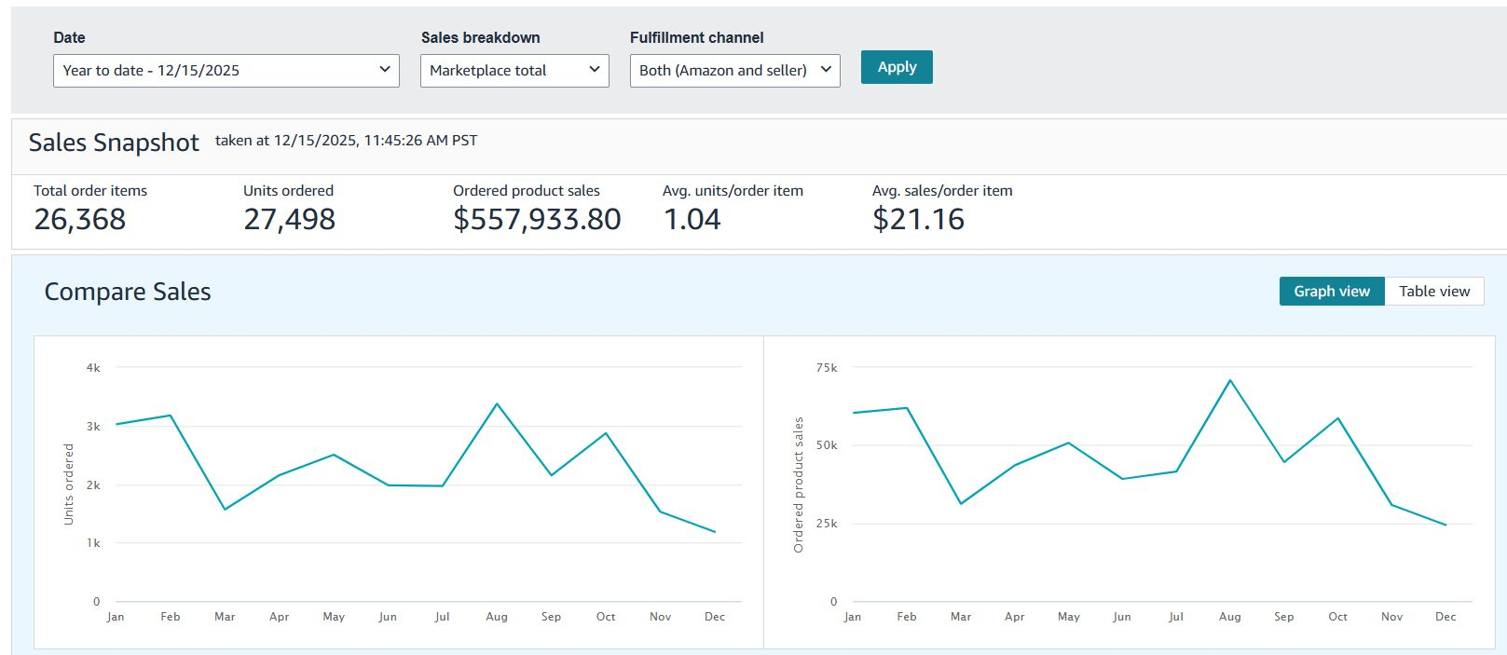

Case Study: 3
Beauty & Personal Care
$𝟭,𝟲𝟭,𝟬𝟬𝟬 𝗦𝗮𝗹𝗲𝘀 𝗬𝗧𝗗 | 𝗡𝗲𝘁 𝗠𝗮𝗿𝗴𝗶𝗻𝘀 $𝟰𝟮𝟬,𝟬𝟬𝟬 𝗡𝗲𝘁 𝗣𝗿𝗼𝗳𝗶𝘁𝘀 (Hook)
𝗠𝗮𝗿𝗸𝗲𝘁 𝗣𝗹𝗮𝗰𝗲: United Stats
𝗡𝗶𝗰𝗵𝗲: Supplements
𝗦𝗮𝗹𝗲𝘀: $1,161,000
𝗦𝗞𝗨𝘀: 17
𝗡𝗲𝘁 𝗘𝗕𝗜𝗧𝗗𝗔: 37.54%
𝐒𝐭𝐫𝐚𝐭𝐞𝐠𝐢𝐜 𝐅𝐨𝐜𝐮𝐬 𝐀𝐫𝐞𝐚𝐬
Product Optimization: Listings were rewritten with clearer titles, enhanced images, and detailed descriptions aligned with customer search behavior.
Advertising Efficiency: Campaigns were rebuilt using data-driven insights. The emphasis was on profitable keywords and refined targeting, improving Ad Sales while reducing wasted ad spend.
Customer Experience: Responding quickly to feedback and addressing pain points improved ratings and built credibility within the electronics niche.
Consistent Monitoring: Sales patterns and seasonality were analyzed monthly, helping forecast inventory and identify high-performing SKUs.
𝐊𝐞𝐲 𝐓𝐚𝐤𝐞𝐚𝐰𝐚𝐲𝐬
Growth in the electronics category requires a balance between experimentation and data discipline.
Organic visibility eventually outperforms paid ads when listings are optimized for both Amazon’s algorithm and real customer intent.
Focusing on customer experience and inventory stability builds trust and consistent performance over time.
Crossing $1.16 million in sales within a single year stands as a milestone achieved through persistence, strategy, and adaptability. From struggling to gain traction early on to consistently maintaining six-figure monthly sales, this journey highlights the power of long-term thinking and continuous improvement in the competitive world of Amazon Supplements.

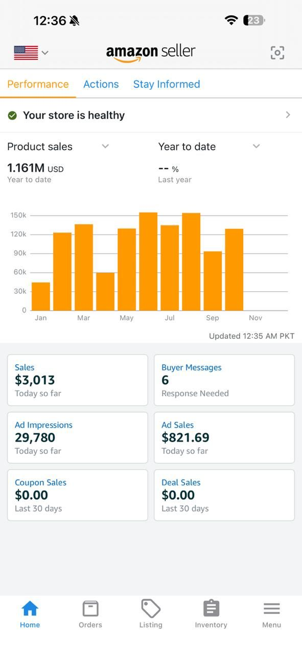

Case Study: 4
Sports & Outdoor
𝗖𝗹𝗼𝘀𝗶𝗻𝗴 $𝟭,𝟱𝟬𝟬,𝟬𝟬𝟬 𝗯𝘆 𝗗𝗲𝗰𝗲𝗺𝗯𝗲𝗿-𝗘𝗻𝗱 𝗮𝘁 𝟭𝟭.𝟲% 𝗧𝗔𝗖𝗢𝗦 | 𝗢𝘃𝗲𝗿 $𝟰𝟮𝟬𝗞 𝗡𝗲𝘁 𝗘𝗕𝗜𝗧𝗗𝗔! (Hook)
𝗠𝗮𝗿𝗸𝗲𝘁 𝗣𝗹𝗮𝗰𝗲: United Stats
𝗡𝗶𝗰𝗵𝗲: Electronics
𝗦𝗮𝗹𝗲𝘀: $1,139,000
𝗦𝗞𝗨𝘀: 13
𝗡𝗲𝘁 𝗘𝗕𝗜𝗧𝗗𝗔: 29.65%
𝐒𝐭𝐫𝐚𝐭𝐞𝐠𝐢𝐜 𝐒𝐡𝐢𝐟𝐭
Optimized Product Listings: Each listing was refined with SEO-friendly titles, high-quality images, and customer-centric descriptions.
Advertising Recalibration: Campaigns were rebuilt around performance metrics—cutting underperforming keywords and scaling proven ones.
Inventory Forecasting: Advanced demand tracking reduced stock outs and overstock situations, ensuring smoother fulfillment.
Customer Feedback Integration: Product improvements were made directly from customer reviews, improving ratings and conversion rates.
𝐊𝐞𝐲 𝐋𝐞𝐚𝐫𝐧𝐢𝐧𝐠𝐬
Sustainable growth comes from clarity, not complexity. Simplifying campaigns and focusing on proven keywords delivered better results than broad targeting.
Inventory discipline is growth’s silent driver. Avoiding frequent stock outs kept rankings stable and improved customer trust.
Data-led advertising wins long-term. While ACOS averaged 40%, each dollar reinvested in optimized ads strengthened organic visibility.
Customer insights are gold. Every product improvement based on feedback directly correlated with review quality and conversion lift.
In just one year, the electronics brand evolved from limited visibility to a thriving Amazon business generating over $1.1 million in sales. Beyond numbers, the transformation reflects persistence, adaptability, and a commitment to continuous improvement.
As 2026 approaches, the focus remains on refining product depth, enhancing brand recognition, and achieving sustainable profitability—turning this year’s success into a long-term benchmark for growth.

